Testing the Effects of Changing the User Principle Name (UPN)

Microsoft’s O365 cloud solution, our soon to be email solution, prefers an authentication method where the user’s UPN and SMTP attributes match. If your application utilizes Active Directory (AD) for any reason you will want to test your application on the effects of the UPN attribute changing.

This can be accomplished by

* using one or two AD test accounts
* provision the test accounts to your application
* validate the test accounts are functional within your application
* make a change to the UPN login name and domain (@cdcr.ca.gov) attributes that make up the UPN attribute
* revalidate the test accounts are still functional within your application.
* report your findings to a EIS AD team member

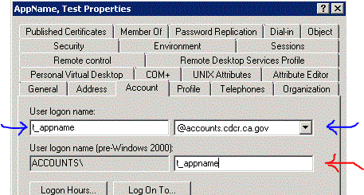

**userPrincipleName (UPN)**

**sAMAccountName**

**(Do Not Change)**

